**Bug Report**

**Date : 04/10/2024**

**Tested By :** Anil

| **Platform** | **Browser** |
| --- | --- |
| Windows 10 | Chrome |

| **Who Detected** | **How Detected** | **Status** |
| --- | --- | --- |
| Quality Assurance | Testing | Open |

| **Founder** | **Bug Id** | **Type** | **Feature** | **Description** | **Steps** | **Severity/ Priority** |
| --- | --- | --- | --- | --- | --- | --- |
| Anil | TB_001 | Bug | Terms and Conditions | Verify that the user must accept the terms and conditions to register. | 1.Visit the URL on the browser/.<https://reebok.abfrl.in>  2.Enter a valid name.  3.Enter a valid email address.  4.Enter a valid password.  5.Confirm the password.   |  | | --- |   6.Do not check the “I agree to the terms and conditions” checkbox.  7.Click the “Register” button. | Critical/  High |
| Anil | TB_002 | Bug | Login with invalid number | Validate phone field on the test form with invalid number . | 1.Visit the URL on the browser/.<https://reebok.abfrl.in>  2.Fill the phone number field with given data  3.click the login button | Critical/  High |
| Anil | TB_003 | Bug | Valid Search Query | Verify that the search bar returns relevant results for a valid search query. | 1.Visit the URL on the browser/.<https://reebok.abfrl.in>  2.Enter a valid product name in the search bar.  3.Click the search icon or press “Enter”. | Major/  medium |
| Anil | TB_004 | Bug | Search with Product Reviews | Verify that the search results display product reviews and ratings.. | 1.Visit the URL on the browser/.<https://reebok.abfrl.in>  2.Enter a query (e.g., “shoes”) in the search bar.  3.Click the search icon or press “Enter”. | Major/  medium |
| Anil | TB_005 | Bug | ISearch Bar Load Time | Verify that the search bar loads within 5 seconds | 1.Visit the URL on the browser/.<https://reebok.abfrl.in>  2.Open the Reebok website.  3.Measure the time taken for the search bar to become interactive. | Major/  medium |
| Anil | TB_006 | Bug | Search Bar Load Time on Different Devices | Verify that the search bar loads within 5 seconds on various devices (e.g., desktop, mobile, tablet). | 1.Visit the URL on the browser/.<https://reebok.abfrl.in>  2.Open the Reebok website on different devices.  3.Measure the time taken for the search bar to become interactive. | Major/  medium |
| Anil | TB_007 | Bug | Checkout with Address Validation | Verify that the system validates the shipping address during checkout | 1.Visit the URL on the browser/.<https://reebok.abfrl.in>  2.Navigate to the cart page.  3.Click the “Proceed to Checkout” button.  4.Enter an invalid or incomplete shipping address.  5.Click the “Place Order” button. | Major/  High |

**Bug ID - TB_004 :**

Search with Product Reviews

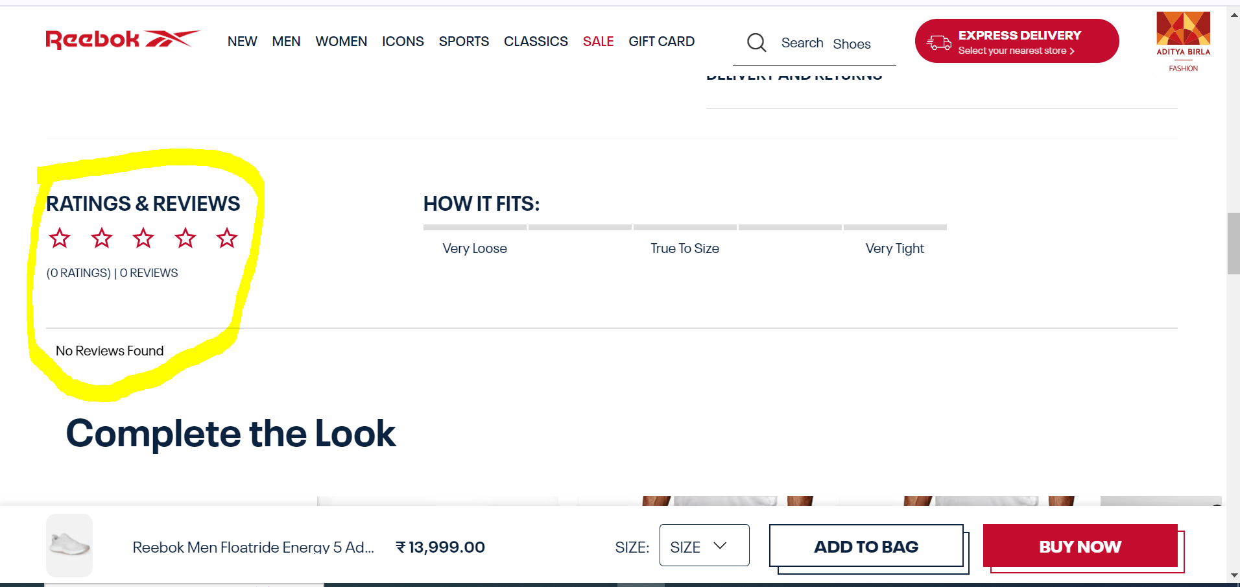

**Bug ID -TB_007**

Checkout with Address Validation

